Section 10 CSS Grid

<https://www.udemy.com/course/the-complete-web-development-bootcamp/learn/lecture/37368434#questions>

**60 Display Grid –**

[**https://developer.mozilla.org/en-US/docs/Web/CSS/CSS_grid_layout/Basic_concepts_of_grid_layout**](https://developer.mozilla.org/en-US/docs/Web/CSS/CSS_grid_layout/Basic_concepts_of_grid_layout)

Can use for difficult layouts like this that are not well suited to flexbox



https://aare.guru/#bern

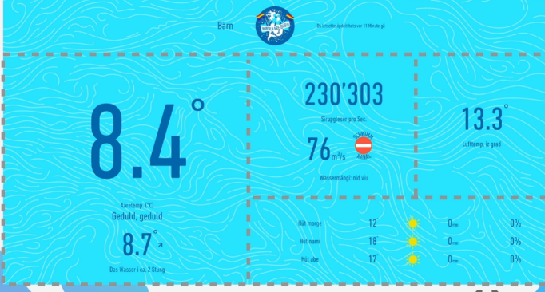

When to use

Flexbox is good to align content along a one dimensional line – 1D

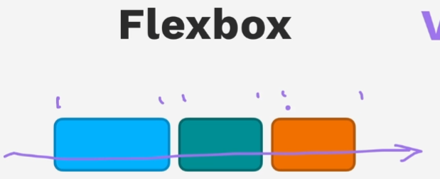

Grid is good for laying out content along a two dimensional grid – 2D

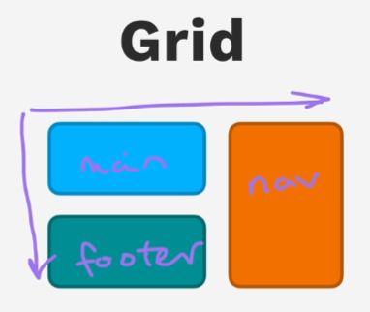

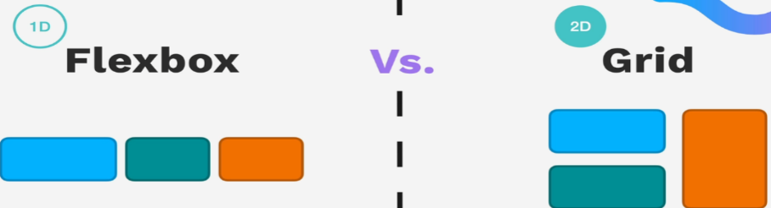

Use them together

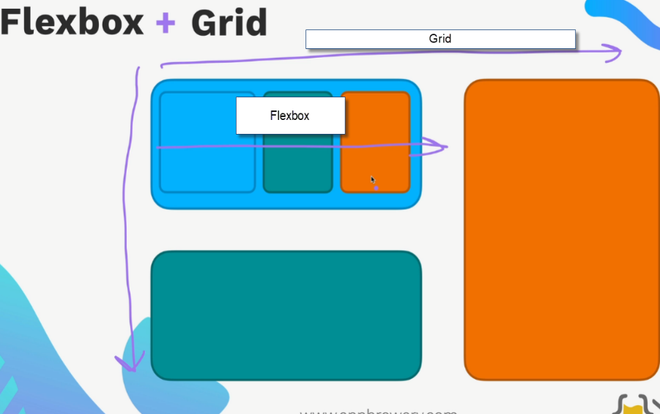

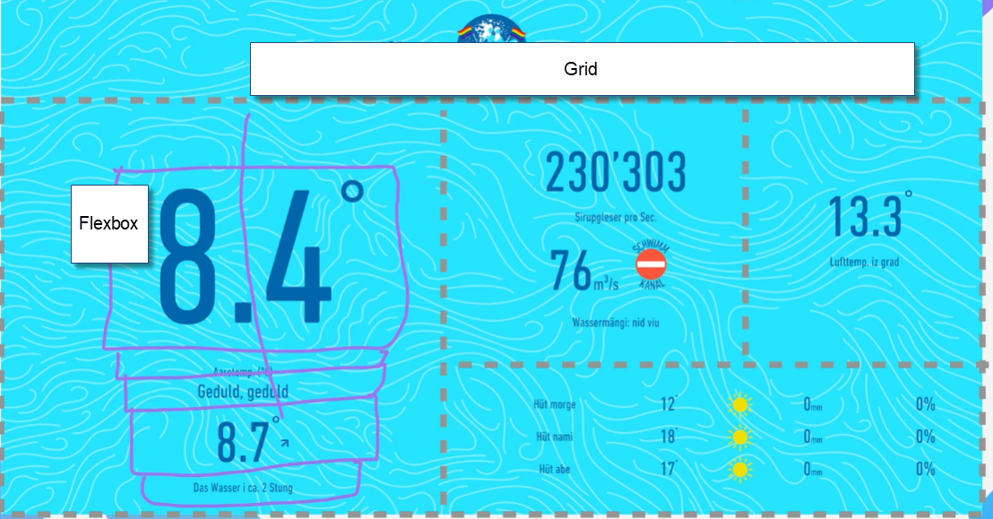

[**https://appbrewery.github.io/grid-vs-flexbox/**](https://appbrewery.github.io/grid-vs-flexbox/)

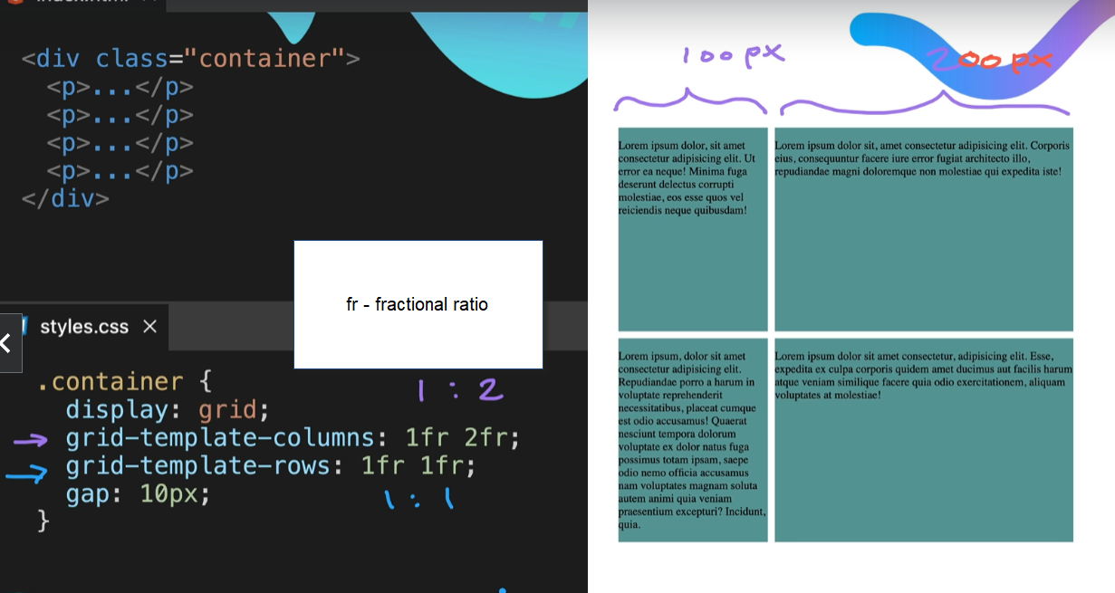

61- Grid Sizing –

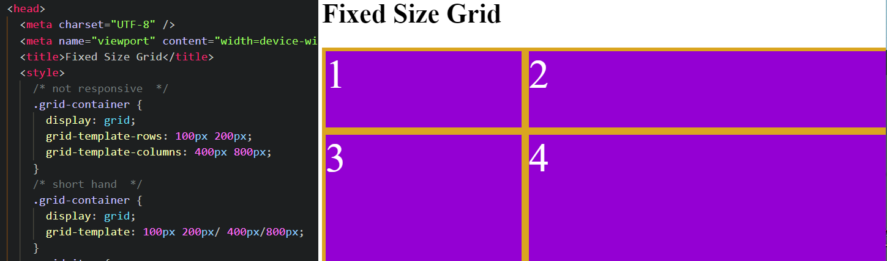

Using the auto keyword give some responsiveness to the grid –

If on column it will try to occupy 100% of the horizontal space , so second column would be extensible

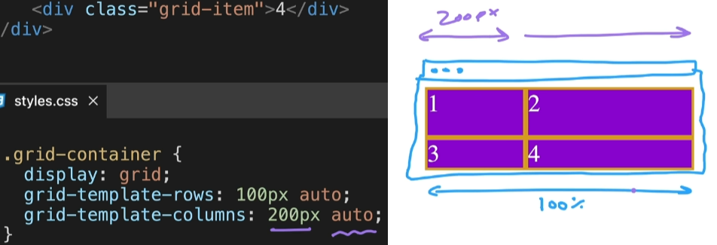

Not the same way for row – it will not occupy 100% of vertical space… It adjusts to fit the height of the content

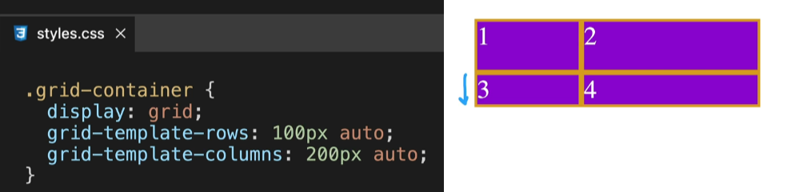



**Fractional** sizing with fr defines the ratios – grid will respond to maintain that ratio based on the content in the div

**Min – max** sizing – sets limits on sizing of columns

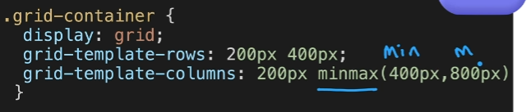

**repeat()** shortcut function to repeat size of each row or column 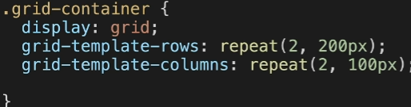

Chrome dev tools can help look at CSS grid 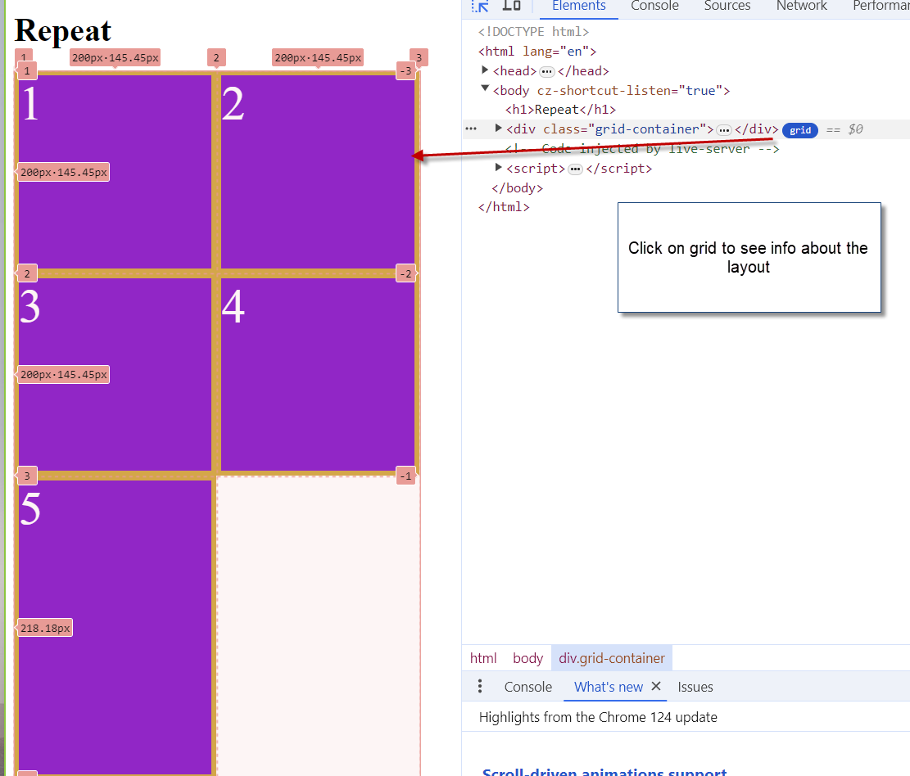

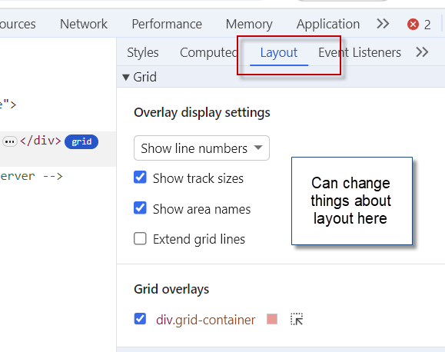

Exercise

<https://appbrewery.github.io/grid-sizing/test.html>

**62 Grid Placement** – layout in the grid

Grid container and grid items

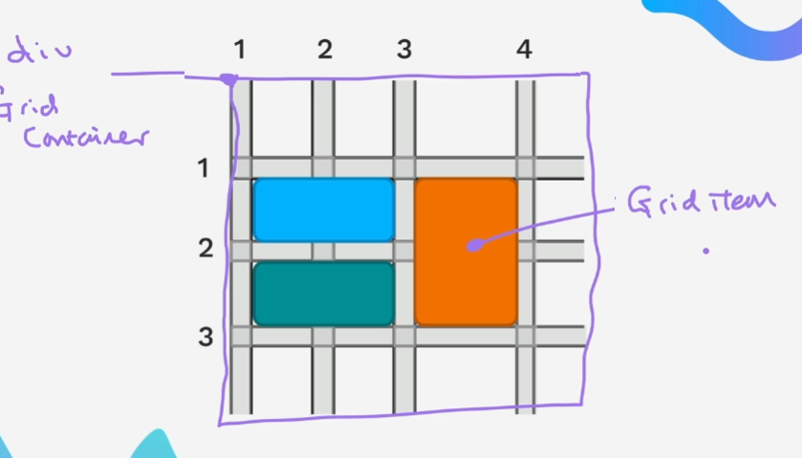

Gird tracks, column and row

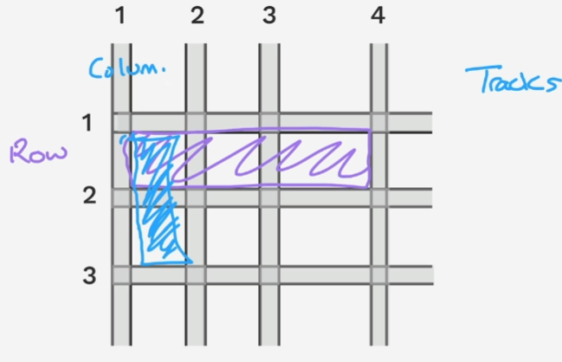

Grid cells -sit between the columns and rows

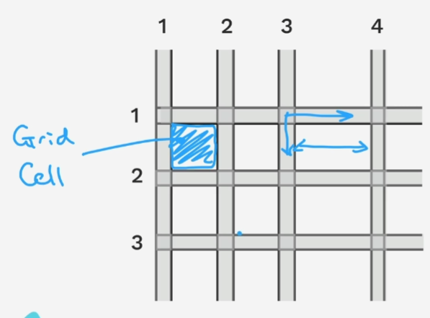

The grid cells can span over the rows and columns

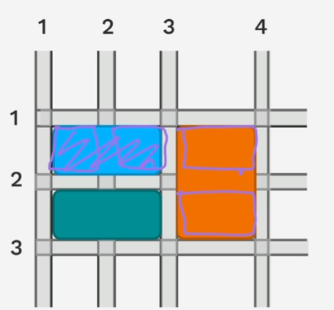

Gird lines – lines that separate the tracks – just space cannot color

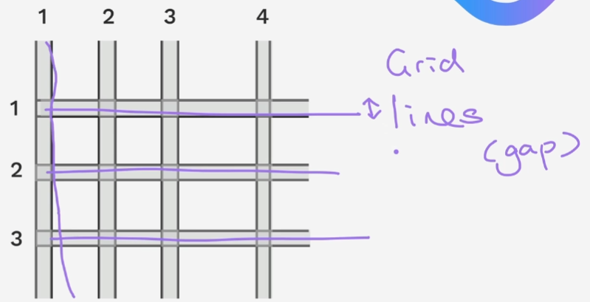

Grid – Lines, Tracks, Cells, Container and items .

Setting the container and tracks

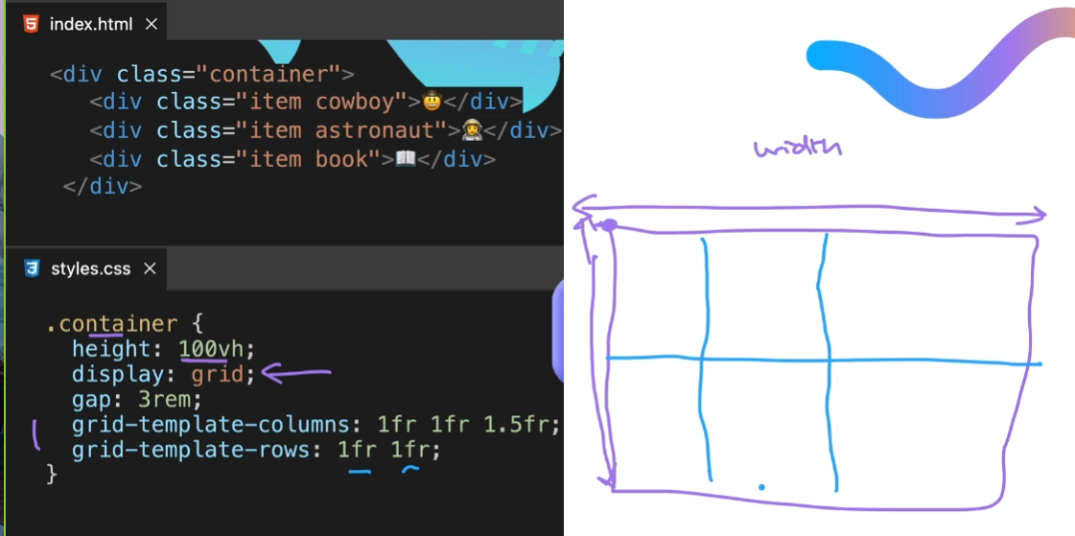

Short hand – if using grid area, all divs should use it

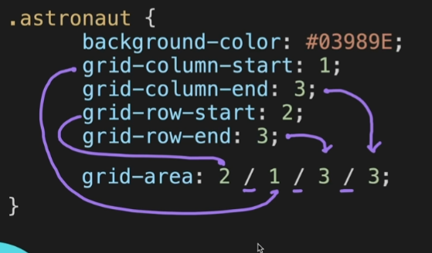

<https://appbrewery.github.io/grid-sizing/>

<https://appbrewery.github.io/gridgarden/>

63 Mondrian Painting –

Restart here

<https://www.udemy.com/course/the-complete-web-development-bootcamp/learn/lecture/37368588#questions/19976794>